|  |
| --- |
| **National University of Computer and Emerging Sciences** |
| In Lab 3  “Introduction to Set Operations and Joins” |
|  |
| Database Systems Lab |
|  |

|  |  |
| --- | --- |
| Course Instructor |  |
| Lab Instructor (s) |  |
| Section |  |
| Date |  |
| Semester |  |

Department of Computer Science

FAST-NU, Lahore, Pakistan

# Exercise

Consider the project like Netflix where users can purchase/rent online movies

>>User has to Signup to use netflix, following information of account holder is save

UserID

Name

EmailAddress

SignupDate

>>A user can rent movies from the available list of movies, following information of movies is maintained

MovieID

MovieTitle

MovieCategoryID (this can be null a movie might not have nay category)

RentalRatePerDay

>>List of categories/ Genre of movie will be kept in this separate table

categoryID

categoryName

>>Following information of rentals is mantained

RentalID

UserID (who rented the movie)

MovieID

RentalStartDate

RentalEndDate

Following diagram shows schema

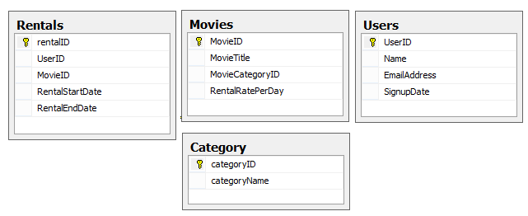

## Task-I

Create the tables for given schema, Also identify and apply FK relationships. Insert the data as given in Appendix A

## Task-II

Write the queries for following statements

1. Display the user ID and name of users from table Users. The names of users should be in uppercase.
2. Show the movie titles and their Rental Rate Per Week.
3. Display the movie Ids that user Id 3 has rented.
4. Display all the users who have rented any movie but no user Id should be repeated in the result. (Hint: ‘Distinct’ keyword).
5. Display the users who have signed up in the year 2017.
6. Display the names and the rental rate of the movies whose rental rate is less than 5.
7. Show the users who have never rented any movie. (Hint: Set Operations).
8. Display the user Ids of those who have rented movies with id 1 and 5.
9. Display the category IDs with no movie listings.
10. Find the Category IDs that have character ‘c’ in category name. Display the index number of character ‘c’ in the name.
11. Display the users who have account on gmail.
12. Display All the category IDs from Movies’ record and their titles. In case a category Id is null, show zero instead.
13. Find the number of days UserId 1 rented movie Id 2.

## Task-III

For this exercise use the following schema, the script to create this schema and populate data is given in ATM.SQL file

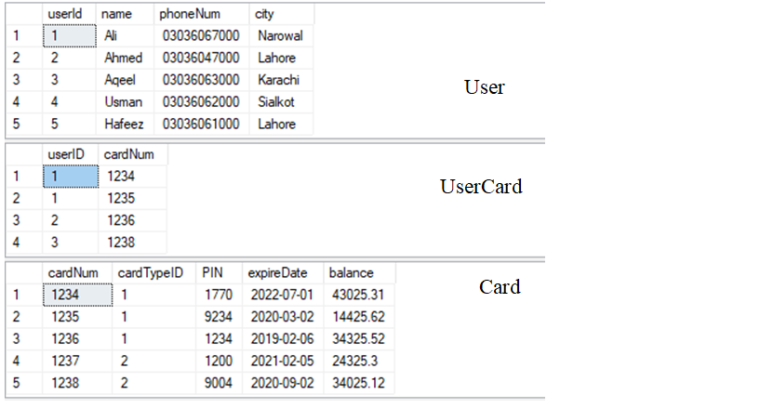

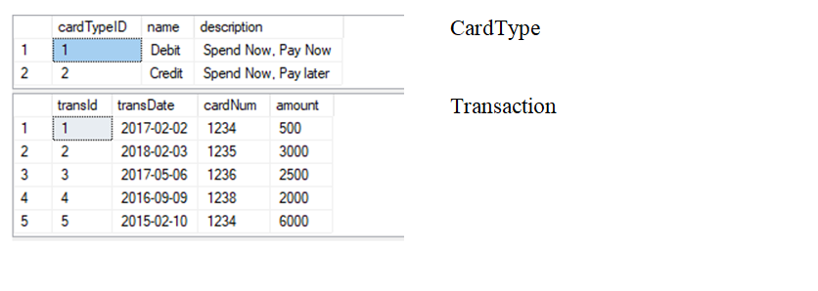

## Task-IV (Using Joins)

1. Show the User names and their Card Numbers.
2. Display the balance of all the card numbers. Also show the card Types(Credit/Debit).
3. Display the card numbers and the transactions. If a card has not done any transaction, show Null.
4. Display all the users, their cards numbers and respective transactions. If a user has not done any transaction, show Null; if a user has no cards, Show Null.
5. Show the name of those users who do not possess any card.
6. Show the number of that card with user name whose balance is in the range (Min: 2000, Max: 4000)
7. List the user id, name, phone number, city of those users whose card is expiring within the next 3 months. Also show the card number along with card type name. (Do not hardcode months)

# Appendix A

Data for Exercise Questions

insert into Users values

(1,'bob','bob@gmail.com','1-1-2016'),

(2,'Tom','tom@yahoo.com','1-2-2017'),

(3,'Alice','alice@gmail.com','1-6-2014'),

(4,'Jim','Jim@ymail.com','1-6-2017')

insert into Category values

(1,'Horror'),(2,'Comedy')

,(3,'Animated')

,(4,'Action')

Insert into Movies

values

(1,'MI-I',4,3.3),

(2,'MI-II',4,4.3),

(3,'MI-III',4,5),

(4,'horton hears a who',3,5.0),

(5,'sherk-2',3,5.0)

Insert into Movies values (6,'xyz',null,10)

Insert into rentals values (1,1,1,'1-6-2019','1-10-2019')

Insert into rentals values (2,1,1,'2-7-2018','2-10-2018')

Insert into rentals values (3,1,2,'3-8-2018','2-13-2019')

Insert into rentals values (4,2,3,'4-9-2019','4-15-2019')

Insert into rentals values (5,3,1,'1-7-2018','1-30-2018')

Insert into rentals values (6,3,5,'2-8-2018','2-21-2018')

Insert into rentals values (7,3,6,'2-8-2019','2-21-2019')